*Internet - Free web iconsFriend Icon Png #282909 - Free Icons LibraryVienna, Billy Joel*

*x11*

*x3*

*x3*

*x2*

*x5*

*x21*

*x11*

*x3*

*x3*

*x14*

*x4*

*x4*

*x11*

*x6*

*x3*

*x3*

*x1*

*x4*

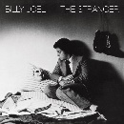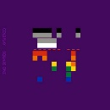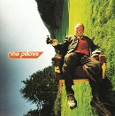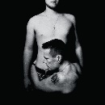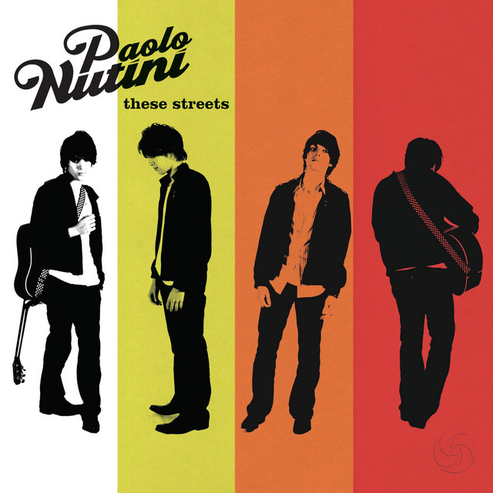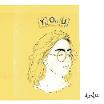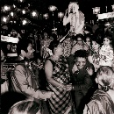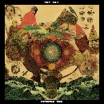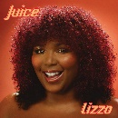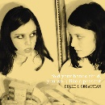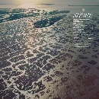

*Internet - Free web iconsSquare One, Coldplay*

dear *alien friend*,

here’s my music taste –  
in a way you’d understand,  
a *data portrait* with love,

Sahil Agarwal  
@sahil.rar

(for Dataviz with IIP – Week 1)

*Internet - Free web iconsFunny Bunny, The Pillows*

*Internet - Free web iconsEvery Breaking Wave, U2*

*Internet - Free web iconsAutumn, Paolo Nutini*



*Internet - Free web iconsWould You Be So Kind, Dodie*

*Friend Icon Png #282909 - Free Icons LibraryMy Mind, Yebba*

here’s my 18 **all-time favourite songs** ordered by when I **first heard** them

the **number** on the left refers to number of times I’ve **shared the song** on WhatsApp.

the **logo** on the top-right edge represents **method of discovery**:

through new release by through a  
the internet followed artist friend

the more willing I am to **dance** to a song, the more **dancer emoticons** besides it.

the **bar’s length**, refers to the **year of** release, i.e. the longer the bar, the more recent the song, eg. Vienna from 1977.

the **colour** of each bar echoes the **emotions** the song evokes, picked from the below gradient:



*Friend Icon Png #282909 - Free Icons LibraryAaftab, The Local Train*

*Internet - Free web iconsPortrait of a Time, Peter Cat Recording Co.*

*Internet - Free web iconsHelplessness Blues, Fleet Foxes*



*Juice, Lizzo*



*Internet - Free web iconsCarry Me Away, John Mayer*

*Internet - Free web iconsLadies and gentlemen we are floating in space, Spiritualized.*



*There’s Too Much Love, Belle and Sebastian*

*I’m Not My Season, Fleet Foxes*

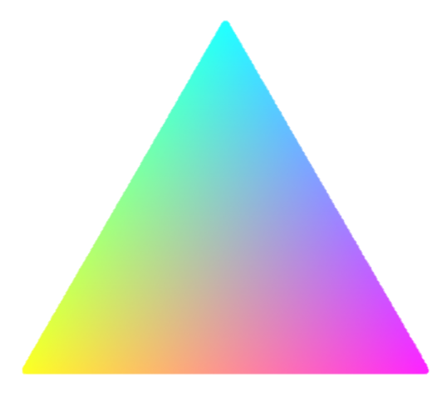

**SADNESS**

**JOY**

**LOVE**

*Internet - Free web iconsAll Too Well (10MV) (TV), Taylor Swift*

*Friend Icon Png #282909 - Free Icons LibrarySuroor, Arooj Aftab*



*Something’s Got A Hold On Me, Etta James*